**How To Install The Realtek Audio Driver In Linux Mint**

If you’re a Linux user, you know that one of the most common things to do after installing a new Linux distribution is to install new drivers. This is especially true for audio drivers, which are often not included by default.  
Fortunately, installing a Realtek audio driver in Linux Mint is a relatively easy process. In this article, we’ll show you how to install the Realtek audio driver in Linux Mint.

When installing the Realtek ALC892 Audio Driver on Linux Mint, enter the root password: so su that you can access your rooted computer. The most recent version of your downloaded driver is called YYY and can be found in the folder title, which is CD realtek-linux-audiopack-5. To use your audio system with sound cards and speakers, you must first install the Realtek High Definition audio driver for Windows 10. When you click the Uninstall button, it will be displayed on the right-click menu of the driver. If the Realtek HD audio manager is not available, a new driver may be required.

Should I still install this? Yes, the answer is yes. The Realtek HD Audio Manager is a useful device for controlling your audio adapters. You can add new devices like speakers, headphones, and microphones automatically to your PC via this software, allowing you to link them at your own convenience.

If you’re using C, navigate to C:/Program Files/Realtek/Audio/HDA. Navigate to RtkNGUI64.exe if you want to use a graphical user interface. You can use the audio manager in the Windows taskbar. If you can’t find the Realtek audio manager, you may need to reinstall the driver for your Realtek HD audio device.

The most common cause of a Realtek HD audio driver failure is that it is out of date or that you are using an incompatible version of the driver. Using Driver Support eliminates the need for manual updating and provides you with a more accurate result.

## How Do I Download Realtek Hd Audio Manager 2021?

To download Realtek HD Audio Manager 2021, visit the official website and click on the “Downloads” section. Choose the “Realtek HD Audio Manager” option and select the appropriate version for your operating system. Follow the on-screen instructions to complete the installation process.

This audio card driver is one of the most popular applications available today. It is compatible with all Windows versions (for example, Windows XP, Windows 7, Vista, 8, 8.1, and 10). After both automatic and manual installations, restart your computer. To access the main interface of the HD Audio Manager, navigate to the Windows taskbar and use the icon. The user interface is streamlined, making it simple to manage sound inputs, mix, coordinate fine grain sounds, and stage the sound. The power management feature is also available for laptops.

The Realtek HD Audio Manager device can be accessed via Device Manager under Sound, Video, and Gaming Devices.  
The Driver tab can be found under the Properties tab.  
Select Uninstall from the Driver tab in the Windows operating system.  
By clicking Yes, you can confirm the uninstallation process.  
After completing the uninstall process, you should restart your computer.  
If you’ve recently updated to Windows 10, you might have noticed that the Realtek HD Audio Manager has been replaced by the new Realtek Audio Driver. You can uninstall and reinstall the Realtek Audio Driver and the old Realtek HD Audio Manager after reading the instructions below. Navigate to Device Manager and right-click the Realtek Audio Driver device to get to the Properties tab.

## How Do I Know If My Realtek Driver Is Installed?

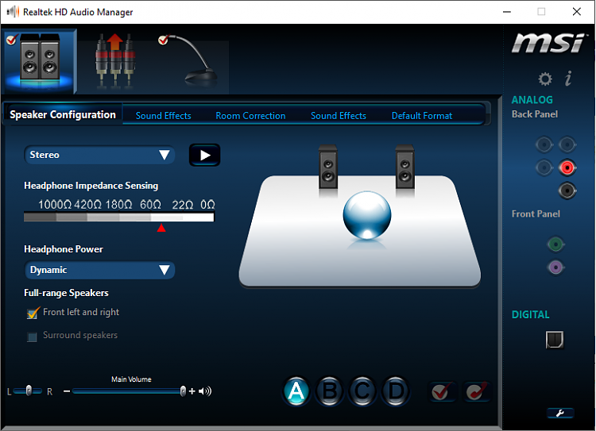Credit: Network and Sharing

By typing ‘device’ into the search box, you can access Device Manager. To expand the list of devices in this category, choose the triangle next to’Sound, video, and game controllers.’ Right-click on it and select Properties. Check the ‘Driver’ tab to see if the driver version is up to date.

Select the appropriate HDA Realtek driver from the Audio – Windows 10 Help Forums. Only those drivers that are built from the ground up (1960s) or have been verified by Realtek HDA (legacy) can be used as either manual or automatic methods. If your system has the default/generic Windows 10 driver installed, you can look for the Audio driver by going to the system’s manufacturer’s support page. You can use the following script to configure automatic detection for the type of Realtek HDA driver required for the installation of your current driver. Take note of the folder where the script was saved in the first place. PowerShell cannot run scripts if the PowerShell ExecutionPolicy is not modified. Check to see if the HDA Realtek driver you downloaded is compatible with your audio device.

You should start each script by following the instructions on this page. Create the log file named RealtekAudioIntegrationDriver.log on your computer. If it does not deliver accurate results, the contents of this thread may be discussed.

## Realtek Audio Driver Linux

https://syscdn.systranbox.com/1661372408380.pngCredit: Network and Sharing

Realtek is a company that manufactures audio drivers for Linux operating systems. The company is based in China and has been in operation since 1987. Realtek audio drivers are used in many popular Linux distributions such as Ubuntu, Fedora, and Mint. The drivers are typically pre-installed on these distributions and provide high-quality sound output.

To install the Realtek ALC892 audio driver for Linux Mint, follow the steps below. Enter the root access code -*xjf LinuxPkg_XXX into the directory. Device Manager’s upper left corner has a menu called the Action menu. If you activate Windows, you can uninstall the Realtek HD Definition Audio driver. If you are unable to find the Realtek audio manager, you must update your Realtek HD audio driver. Linux has the Advanced Linux Sound Architecture (ALSA) in place, which allows the program files to be stored in the program directory as well as the audio directory.

## Linux Audio Driver Install

There are a few different ways to install audio drivers on Linux-based systems, but the most common is to use the command line. To do this, first open a terminal window and then enter the following command: sudo apt-get install alsa-utils. This will install the ALSA Utilities package, which contains a number of tools for managing audio on Linux. Once the package is installed, you can then use the alsamixer command to adjust the volume levels for your audio device.

All Linux distributions, including Linux-sound-base and Ubuntu Linux-base, will install automatically. Linux’s Advanced Linux Sound Architecture (ALSA) allows you to manage sound output in Ubuntu. The three answers to each of these questions must be read, the ALSA packages must be uninstalled, and the work must be restarted. To reinstall the packages listed below, please follow the steps outlined below.

## Linux Mint Sound Drivers

Linux Mint is an Ubuntu-based distribution whose goal is to provide a more complete out-of-the-box experience by including browser plugins, media codecs, support for DVD playback, Java and other components. It also adds a custom desktop and menus, several unique configuration tools, and a web app manager.  
Linux Mint is one of the most popular distributions available, and for good reason. It’s easy to install and comes with everything you need to get started using your computer. One area where Linux Mint shines is in its support for sound drivers.  
If you’re using Linux Mint, you can rest assured that there are drivers available for your sound card. In fact, Linux Mint includes a tool that makes it easy to install drivers for your hardware.  
To access this tool, open the mintMenu and select Driver Manager. From here, you can see a list of drivers that are available for your hardware. If there is a driver available for your sound card, it will be listed here.  
If you’re not sure which driver you need, you can also use the Search function to find drivers that are compatible with your hardware. Simply enter your hardware model or manufacturer in the search box and click the Search button.  
Once you’ve found the driver you need, click the Install button and follow the instructions to install the driver. After the driver is installed, you should be able to use your sound card without any problems.

The same issue has occurred with GT430 and HDMI audio not working, as well as the Dual boot system LM11/64 and winXPSP3 sound working. It is impossible for me to install it. Driver 275.19 should be run. It appears to be searching for libc in the results. This folder is named /lib/. When I changed the probe_mask value in alsa-base.conf, I noticed that the number of hdmi devices available had been reduced. After discovering the field was a mask, I used the value 8 to specify only the fourth device (device 3).

### How To Resolve Driver Problems In Linux Mint

If a hardware device is not detected, you may need to install the appropriate driver. If you need any further assistance, please refer to the Linux Mint documentation.  
If your Realtek audio is not working, you may be using an incorrect or outdated driver. It is possible to resolve the problem by updating or reinstalling the driver. When you use Driver Easy, you can select the correct driver and install it. If your hardware device is not detected, you must consult the Linux Mint documentation for additional assistance.

## Realtek Sound Drivers

If you have a computer that uses Realtek sound drivers, you may need to update them periodically to ensure that your computer’s audio quality remains high. You can typically find the latest drivers on the Realtek website, or through your computer’s manufacturer.

Many OEM computer brands use Realtek as an audio solution. There is a website where you can download the most recent driver from Realtek, but it can be a little difficult to manually do if you are unfamiliar with operating systems or programming. The following are some of the most common solutions for Realtek audio driver issues and installation issues. To update your drivers, you’ll need some skills and patience. The Premium version of DriverSupport allows you to automatically update the Realtek Sound Drivers. Click the FIX IT button to enable the updating of your Realtek audio devices drivers on your computer.

## Realtek Alc892

The Realtek ALC892 is a high-definition audio codec with support for multiple audio channels. It is used in a variety of devices, including laptops, motherboards, and sound cards. The ALC892 supports up to eight channels of audio, and offers a variety of features, including support for multiple audio input and output jacks, support for multiple audio codecs, and support for multiple audio file formats.

There are a few findings I’ve gathered from the few weeks I spent trying it out. Chip’s SNR is 120dB, but in reality, it drops to around 90dB, which is enough for CD quality audio. If you only want to get rid of the noise, a DAC connected via optical SPDIF or wireless is the way to go. Most ALC1220 boards are equipped with a Toslink connector capable of receiving a 24-bit 192 kHz signal. You can’t go wrong with an external USB DAC or an expensive shielded internal card.

### What Is The Latest Realtek Driver Version?

As a result, the most recent version of the Realtek HD Audio driver is R2. The game was released on July 26th, 2017.

#### You Need The Realtek High Definition Audio Driver Depending On Your Windows Operating System

If you use a Windows 10 operating system and have the Realtek ALC1150 audio controller, you must install the Realtek High Definition Audio Driver. If you have a Realtek ALC1150 audio controller installed in Windows 8.1, the High Definition Audio Driver must be installed. To use the Realtek High Definition Audio Driver on Windows 7, you must have the Realtek ALC1150 audio controller.